WAFB’s Stunning Rescue Video Brings World’s Attention to Flooding
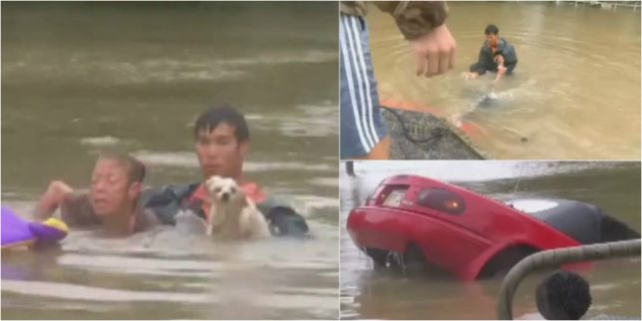
WAFB’s dramatic video, shot by reporter Robbie Reynold, of a man rescuing a woman and her dog from a submerged car was the most engaged post on Facebook in the world on Saturday and Sunday, according to Rob Hays, news director of the Raycom-owned CBS affiliate in Baton Rouge, La.
TVNewsCheck/MarketShare 8.16.16
http://www.tvnewscheck.com/marketshare/2016/08/16/wafbs-stunning-rescue-video-brings-worlds-attention-to-flooding/

