Walgreens Launches Retail Media Network
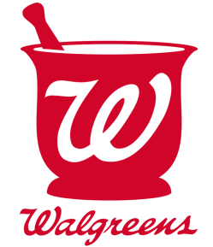
Walgreens is joining into the retail ad network fray with its Walgreens Advertising Group, which enables partners to use a proprietary programmatic demand-side platform to reach its in-store and online shoppers via video, social media, streaming audio and email channels and outside channels including Facebook, Google and Pinterest. Media buyers also can access customized audience segments via collaboration with Adobe and Microsoft.
Marketing Dive 12.3.20
https://www.marketingdive.com/news/walgreens-debuts-retail-media-network-with-revamped-loyalty-program-front/591550/

