Walmart Reports Success Connecting With TikTok
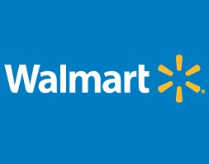
Walmart reported doubling engagement from TikTok benchmarks with a pilot partnership between the platform and in-house agency Walmart Connect, using first-party data that it collects in stores as well as online. The combination gives marketers "a holistic view of the Walmart shopper," noted McMillanDoolittle, which recently gave Walmart an Innovation Award.
Talk Business & Politics (Little Rock, Ark.) 2/18/24
https://talkbusiness.net/2024/02/the-supply-side-walmart-connect-targets-6b-in-ad-revenue-by-2025/

