Warner Bros. Gets Wrist Slap from FTC on Ad Disclosure
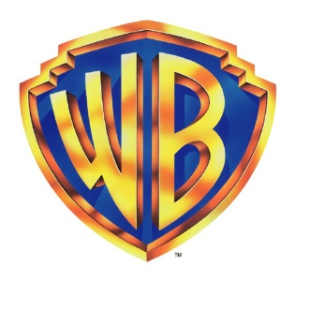
The Federal Trade Commission has reprimanded Warner Bros. for not labeling sponsored content produced by influencers to promote the video game "Middle Earth: Shadow of Mordor." The company was warned by the FTC not to pass off any future advertising as the "objective, independent opinions of video game enthusiasts or influencers."
Marketing Land 7/12/16
http://marketingland.com/ftc-spanks-warner-brothers-failure-disclose-influencer-payments-184131

