WarnerMedia's Turner Extends Deal with MLB
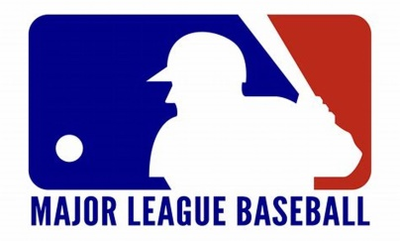
A rights deal extension with a value reportedly exceeding $3 billion will see WarnerMedia subsidiary Turner Sports carry more Major League Baseball games and increase its platforms' MLB-related digital content. The terms of the seven-year deal, which prolongs the partnership through 2028, remained undisclosed.
The Hollywood Reporter 9.24.20
https://www.hollywoodreporter.com/news/mlb-turner-sports-extend-tv-rights-deal-through-2028

