Was That A Russian Spy, Or Am I Getting Paranoid?
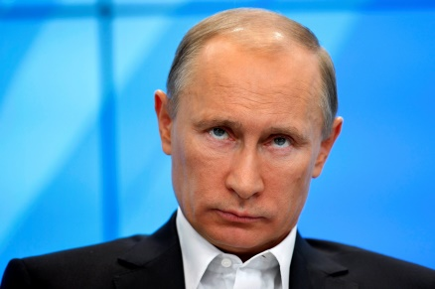
When you start packing for a reporting trip to Russia, you get a lot of advice. Take a clean phone, advised my journalist friends in Moscow. Take a clean laptop. That means one that has been wiped and re-imaged and from which I've never logged on with my usual user accounts and passwords. The reason? Russian intelligence will be monitoring you from the moment you land, they said.
National Public Radio 7.26.16
http://www.npr.org/sections/parallels/2016/07/26/487049242/was-that-a-russian-spy-or-am-i-getting-paranoid?utm_source=API+Need+to+Know+newsletter&utm_campaign=075a278612-Need_to_Know_July_27_20167_27_2016&utm_medium=email&utm_term=0_e3bf78af04-075a278612-31697553

