Watchdogs Ask FTC to Act on Undisclosed Instagram Ads
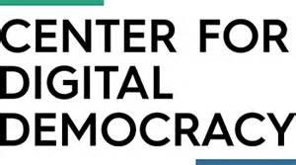
Commercial Alert, Public Citizen, the Center for Digital Democracy and Campaign for a Commercial-Free Childhood are urging the Federal Trade Commission to do something about celebrities who are still not adequately disclosing paid endorsements on Instagram. Public Citizen reviewed the Instagram posts of 46 celebrities who received letters from the FTC warning them about disclosure and found that just one was consistently following the rules.
MediaPost Communications 6/26/17
https://www.mediapost.com/publications/article/303461/celebrities-still-fail-to-disclose-instagram-ads.html

