No Sign Of Breakthrough As WGA, AMPTP Meet
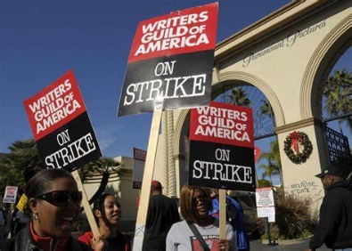
Representatives for the Alliance of Motion Picture and Television Producers and the Writers Guild of America met on Friday but failed to agree on resuming negotiations to end the ongoing strike action. The meeting was the first between the organizations in at least three months.
Deadline Hollywood 8/4/23
https://deadline.com/2023/08/writers-strike-meeting-union-studios-no-new-talks-1235455349/
Image credit:
https://internewscast.com/wp-content/uploads/2023/08/Writers-Guild-Strike-Not-Expected-To-Be-Resolved-Anytime-Soon.jpg

