What 5G Means for Digital Advertisers
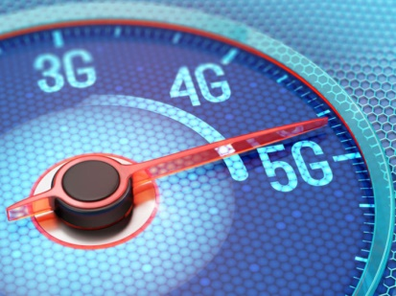
The introduction of 5G will speed up ad-loading times on mobile and desktop, which could lead to a decrease in the use of ad blockers as the user experience improves, says DDG's Scott Singer. Others say the technology will herald new ad pricing and formats, with The Community's Chris Neff predicting that "the depth of how we can communicate to consumers will expand, and with the expansion, comes more premium options."
Digiday 6/29/18
https://digiday.com/marketing/5g-coming-will-change-digital-advertising-ways-think/
Image credit:
https://images.techhive.com/images/article/2017/04/5g-100719145-large.jpg

