What 5G Networks Mean for Mobile Marketers
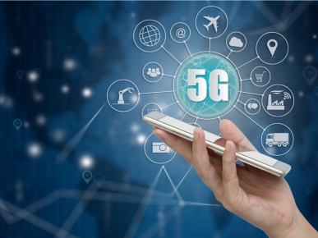
Leading telecommunication companies are just starting to utilize a 5G wireless network, which is 10 times faster than 4G, that will affect the customer experience individuals have interacting with mobile marketers, writes Indrajeet Deshpande. He predicts as the technology becomes more ubiquitous individuals will rely more on their speedier mobile phones and use fewer ad blockers because of fast download times; and marketers will be able to seamlessly integrate mobile and in-store interactions, providing a more interactive and immersive experience.
MarTech Advisor 8/12/19
https://www.martechadvisor.com/articles/mobile-advertising/5g-impact-mobile-marketing-customer-experience/
Image credit:
https://www.pandasecurity.com/mediacenter/src/uploads/2018/12/pandasecurity-5G-cybersecurity.jpg

