What Ballooning Carbon Emissions Will Do to Trees
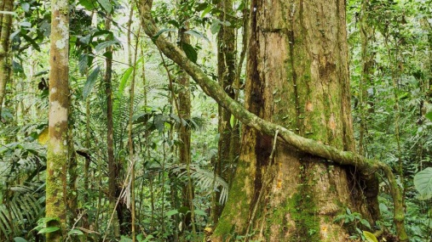
By some estimates, the band of jungle that hugs the equator sucks up about half of the carbon absorbed on land. But in the coming years, tropical regions are projected to see steeply rising temperatures and, in some areas, increased drought. That will create less and less hospitable conditions for these crucial equatorial jungles.
Pulitzer Center 11.25.19
https://pulitzercenter.org/reporting/what-ballooning-carbon-emissions-will-do-trees?utm_source=newsletter&utm_medium=email&utm_campaign=11262019
Image credit:
https://kids.nationalgeographic.com/content/dam/kids/photos/articles/Nature/H-P/Habitats/Rain-Forest/rain-forest-vines.adapt.945.1.jpg

