What Netflix's Horrible Quarter Means for the Rest of the Streaming Sector
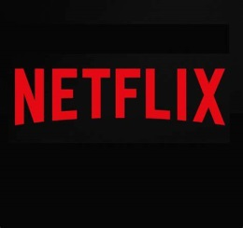
Make no mistake, Netflix's catastrophic Q1 earnings report Tuesday marks an inflection point for the entire video industry. Netflix shares dropped 36% after the company said subscriber totals fell slightly (200,000 accounts) for the first quarter, and were expected to drop 10 times as much for the second quarter. Those would be the first quarters in a decade where Netflix didn't see its subscriber rolls grow. Wall Street was suitably dismayed.
Next TV 4/20/22
https://www.nexttv.com/news/the-partys-over-what-netflixs-horrible-quarter-means-for-rest-of-streaming-sector-bloom?utm_source=SmartBrief&utm_medium=email&utm_campaign=C74FC4FA-5D4D-4151-8915-3043BA411DBE&utm_content=B6BAA1D0-98C3-459E-AA3F-E8C79F32297B&utm_term=a25693a1-51b6-4112-bde4-56bd420e983f

