What the Response to Potential Uber Ban in London Says About Brand Trust
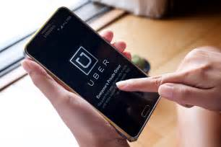
Zone's Jon Davie writes about the complexity of brand trust and how the reaction of young women to Transport for London's proposed suspension of Uber in the city illustrates that consumers are shifting from trusting groups and organizations to technology, even when a brand may have questionable ethics. "[I]f we trust code more than we trust companies, what does that mean for the future of your business?" he asks.
The Drum (Scotland) 10/4/17
http://www.thedrum.com/opinion/2017/10/04/why-brand-trust-no-longer-clear-cut-issue
Image source:
https://www.bing.com/images/search?view=detailV2&ccid=yJROTGEH&id=0C1F426686BE1945A1368942393D5C3F2C832221&thid=OIP.yJROTGEHF6La3OvqiOeK4wEyDM&mediaurl=https%3A%2F%2Fwww.cryptocoinsnews.com%2Fwp-content%2Fuploads%2F2016%2F02%2FUber-phone.jpg&exph=666&expw=1000&q=UBER+ON+PHONE&selectedindex=11&ajaxhist=0

