WhatsApp Awards $1 Million for Misinformation Research
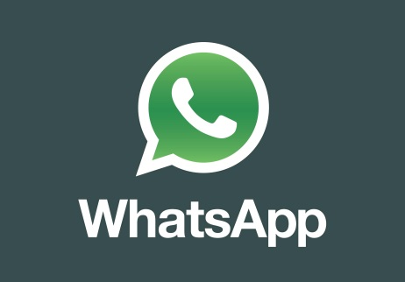
The Facebook-owned company announced that it’s awarding $50,000 each to 20 research projects from 11 countries, for a total of $1 million. “We recognize this issue presents a long-term challenge that must be met in partnership with others,” said Mrinalini Rao, lead researcher at WhatsApp. “These studies will help us build upon recent changes we have made within WhatsApp and support broad education campaigns to help keep people safe.”
Poynter 11.12.18
https://www.poynter.org/news/whatsapp-awards-1-million-misinformation-research?utm_source=API+Need+to+Know+newsletter&utm_campaign=a8b62b0f1c-EMAIL_CAMPAIGN_2018_11_14_01_08&utm_medium=email&utm_term=0_e3bf78af04-a8b62b0f1c-31697553

