White House Announces Broadband Subsidies
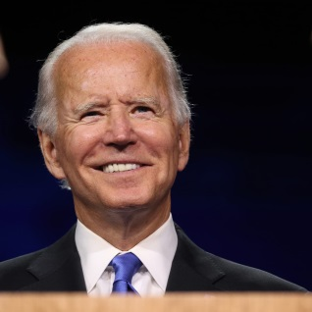
An initial group of 20 companies, including Comcast, Charter Communications and Cox Communications, has joined President Joe Biden's new affordable internet program. The initiative will offer broadband at $30 per month, meaning that Affordable Connectivity Program subsidies will cover the cost for as many as 48 million homes in the country.
The Associated Press 5/9/22
https://apnews.com/article/technology-business-132d8f9709979039c8ea310273b672af
Image credit:
https://annsvg.com/the-content/uploads/2020/11/img_5075.jpg

