White House's New Broadband Maps Show Service Gaps
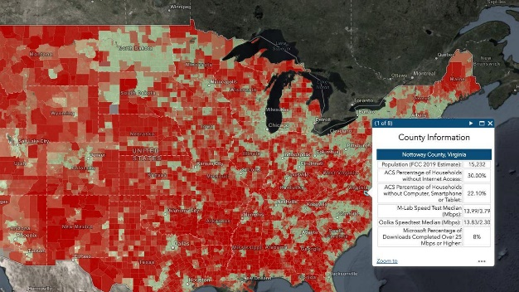
A mapping tool that the White House recently unveiled shows larger gaps in high-speed service availability than previous models did, adding force to President Joe Biden's broadband infrastructure proposal. The Federal Communications Commission, Ookla, the Census Bureau, M-Lab and Microsoft were among those contributing data to the project.
Axios 6/17/21
https://www.axios.com/broadband-maps-infrastructure-66a91da4-c0f4-415c-8e84-1f58b829b323.html
Image credit:
https://s.yimg.com/uu/api/res/1.2/ecWSofVavVcP6bYLG3.LVQ--~B/aD03MjA7dz0xMjgwO2FwcGlkPXl0YWNoeW9u/https://media.zenfs.com/en/axios_articles_623/784407663c42b721ae046eb505b46300

