Why Brands Are Betting On Mobile Gaming Integrations
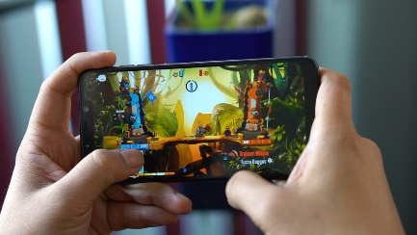
Zynga and e.l.f. Beauty are tapping into mobile games to capture consumer attention amid a fragmented media landscape and build relationships through two-way interactivity. Zynga's Gabrielle Heyman says gaming integrations enable brands to connect with all demographics, and when a brand "helps a gamer become more successful in their game and be able to win more, it really impacts people's memory and perception of that brand."
Adweek 2/17/22
https://www.adweek.com/brand-marketing/power-of-engagement-in-mobile-gaming/
Image credit:
https://cellularnews.com/wp-content/uploads/2020/02/Featured-Mobile-Gaming.jpg

