Why Brands Are Singing Their Own Tunes On TikTok
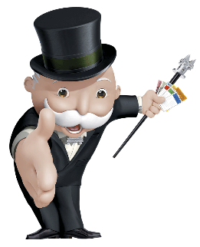
Brands are introducing custom audio branding on TikTok to stand out and create traction among consumers, such as Hasbro's "Mr. Monopoly" tune and Madewell's song about jorts. Today's audio efforts feature branding that's often covert, avoids the hard sell and sparks consumer involvement, say experts.
Marketing Brew 10/10/23
https://www.marketingbrew.com/stories/2023/10/10/tiktok-helped-revive-the-marketing-jingle-just-don-t-call-it-that
Image credit:
https://clipground.com/images/monopoly-png-5.png

