Why Dark Social Matters for Brands
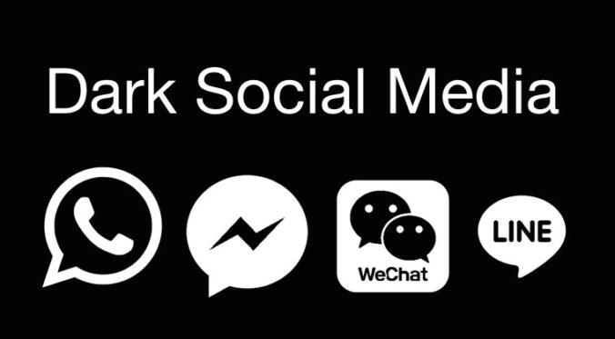
Marketers must come to grips with dark social -- messaging and content sharing performed via emails or messenger apps -- to find out about hidden brand audiences and their interests, David Cohn writes. Dark social communities "function more as focus groups" and "provide an honest, inside view into what tastemakers and potential customers are thinking and sharing," he writes.
MediaPost Communications 10/22/18
https://www.mediapost.com/publications/article/326881/marketing-to-a-dark-social-world.html
Image credit:
https://latenightparents.com/wp-content/uploads/2018/05/dark-social-media-676x373.jpeg

