Why Lifetime is Experimenting with a Direct-To-Consumer Service
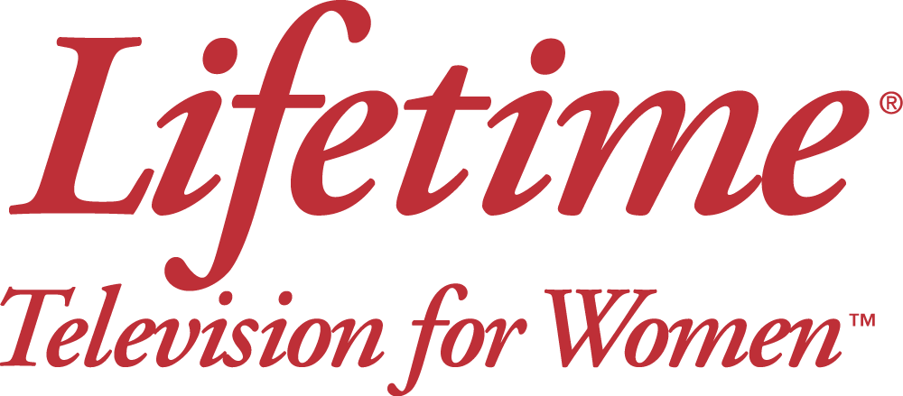
Lifetime's new Movie Club service, which makes certain original movies available a year after they debut, isn't a potential pay-TV game-changer akin to HBO and Showtime's comprehensive over-the-top streaming services, Andrew Wallenstein writes. However, the service does give Lifetime a way "to stick an oar into the OTT waters" and "move toward a future in which there's a direct-to-consumer relationship," Wallenstein writes.
Variety 7/3/15
http://variety.com/2015/tv/opinion/lifetime-movie-club-ott-hbo-now-1201533338/

