Why Live Sports is Ripe for Interactive Engagement
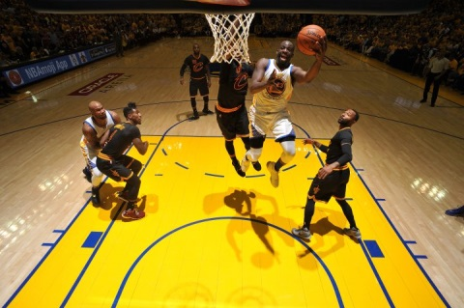
Live sports is one arena where the potential of mixed reality to engage consumers is being realized, exemplified by the connected stadium of the NBA's Sacramento Kings that offers augmented reality games using the actual court during halftime, Mateusz Przepiorkowski writes. Other examples include the NBA's virtual reality experience during this year's playoffs and "[b]rands shouldn't be afraid of exploring creative ideas that push the limits of technical innovation to grab fans attention," he writes.
VentureBeat 9/13/18
https://venturebeat.com/2019/09/13/mixed-reality-is-boosting-the-live-sports-experience/
Image credit:
https://fortunedotcom.files.wordpress.com/2016/07/gettyimages-541510606.jpg?w=720&quality=85

