Why Social Media Users Are Becoming More Private
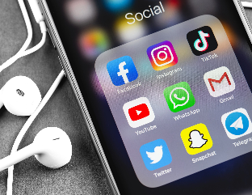
As social media, and Instagram in particular, become more of an "aspirational entertainment" space, dominated by carefully curated content posted by influencers and brands, non-creators are posting less and turning instead to private messaging and closed communities within the platforms to bond with friends, family and others who share niche interests
Insider 8/30/23
https://www.businessinsider.com/social-media-dead-instagram-tiktok-bereal-replaced-group-chats-messaging-2023-8
Image credit:
https://www.webtms.com/wp-content/uploads/2020/08/Social-media-v2-scaled.jpg

