Why Taking a Stand is Right for Some Brands
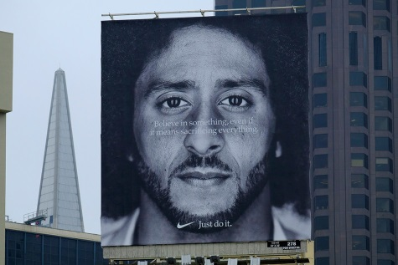
Brands such as Dick's Sporting Goods and Nike have benefited from taking a stand on social issues such as gun violence and racism, and even negative social commentary can be good for brand development, as it galvanizes loyal fans and increases awareness, per research from Y&R's BAVSocial. "Nike and Dick's have garnered significant support because their beliefs and how they communicate them align with their brand promise," said Y&R and BAV Group's Kyle Boots.
Campaign US 9/21/18
https://www.campaignlive.com/article/brands-benefit-polarization/1493443
Image credit:
https://pmcfootwearnews.files.wordpress.com/2018/09/nike-colin-kaepernick-billboard-san-francisco-california.jpg

