Why the Music Industry, Fans are Embracing Chatbots
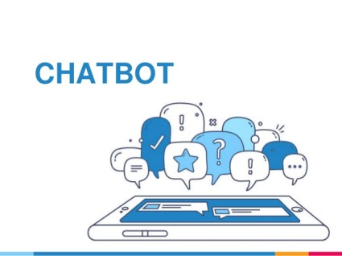
Music artists such as Maroon 5, Aerosmith, 50 Cent and Snoop Dogg are all engaging with fans via chatbots on Facebook Messenger. Singer and actor Christina Milian says the artificial intelligence captures her personality, noting, "When I'm communicating with my own chatbot ... sometimes I see something and I'm like, 'Oh, that's so me!' "
The New York Times 4/3/17
https://www.nytimes.com/2017/04/03/business/media/its-not-their-pop-idol-but-a-bot-fans-cheer-anyway.html?WT.mc_id=SmartBriefs-Newsletter&WT.mc_ev=click&ad-keywords=smartbriefsnl&_r=0
Image source:
http://image.slidesharecdn.com/chatbot-161220142338/95/chatbot-what-is-it-1-638.jpg?cb=1482243979

