Will the FCC's Incubator Program Help in Media Ownership Battle?
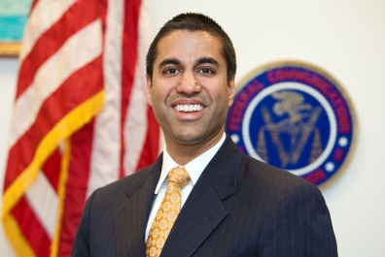
The Federal Communications Commission's incubator program to bolster diversity could help in the fight for media ownership reform. Though FCC Chairman Ajit Pai hasn't indicated whether he believes the program will help with efforts to repeal media ownership limits, he noted that he is "pleased that working together with public interest advocates we were able to once and for all make a stand in favor of diversity in terms of official action."
Inside Radio 8/8/16
http://www.insideradio.com/free/fcc-s-incubator-factors-into-fight-over-media-ownership/article_f0e0e216-9ad8-11e8-bdce-2b487b1ebefd.html
Image credit:
http://www.pulseheadlines.com/wp-content/uploads/2017/02/Ajit-Pai-FCC.jpg

