Women Are In charge: How TV Production is Evolving
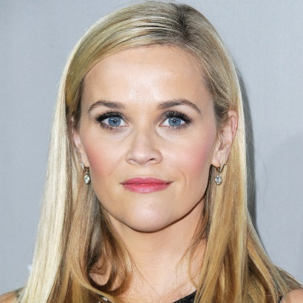
Recent events have seemingly led to a wave of new female-fronted and female-focused production companies. In the US, Nina Tassler has created content biz Patma, Double Yay Productions appeared out of a Kickstarter campaign in the UK, and over in Scandinavia Bigster was born out of a TV royalty trio, including actor Alexandra Rapaport and senior regional producers.
TBI Vision 4.4.18
https://tbivision.com/2018/04/04/women-are-in-charge-how-tv-production-is-evolving/
Image credit:
http://cdn3.thr.com/sites/default/files/2015/12/reese_witherspoon_gettyimages-497228844.jpg

