Women Journalists and Online Harassment
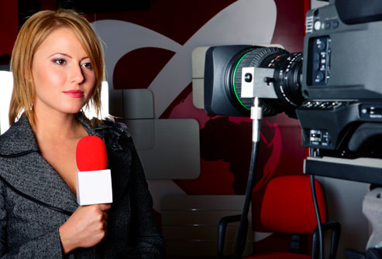
Women journalists face the threat of online harassment as they do their jobs of trying to engage with their audience over social media. This harassment can be different from what male journalists face because it can target women based on their gender or sexuality.
Center for Media Engagement – U. of Texas at Austin
https://mediaengagement.org/research/women-journalists/?utm_source=API+Need+to+Know+newsletter&utm_campaign=02e8b1fb0b-EMAIL_CAMPAIGN_2018_04_12&utm_medium=email&utm_term=0_e3bf78af04-02e8b1fb0b-31697553
Image credit:
https://alonasmorning.files.wordpress.com/2015/04/thinkstock_rf_female_reporter.jpg

