UNESCO Makes Peace The Focus Of World Radio Day
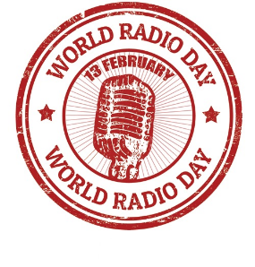
"Radio and Peace" will be the theme of this year's World Radio Day on Feb. 13, the United Nations Educational, Scientific and Cultural Organization has announced. UNESCO says radio stations can incorporate themes of peace into their programming and review editorial policies to examine how they contribute to peace efforts worldwide.
Radio World 1/18/23
https://www.radioworld.com/global/how-are-you-celebrating-world-radio-day?utm_term=A25693A1-51B6-4112-BDE4-56BD420E983F&utm_campaign=45863C53-9E40-4489-97A3-CC1A29EF491D&utm_medium=email&utm_content=7AD49F8C-2B7D-4F28-ABE1-E0D80328C88C&utm_source=SmartBrief

