Public-Access Station Helps the Underserved
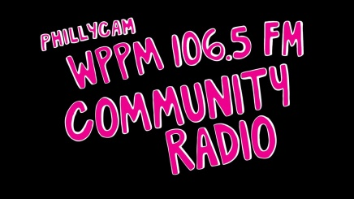
Philadelphia’s new radio station, low-power, public-access WPPM — as in “People Powered Media” — is inventing itself in a hurry. It’s charged with serving the under-served and providing unique and educational points of view and information. The 90-watt signal at 106.5 FM should reach about half the city — from Center City north to Lehigh Avenue, south to the sports stadiums, west to University City, and east to Camden and Cherry Hill.
Philadelphia Inquirer 8.9.16
http://digital.olivesoftware.com/Olive/ODN/PhiladelphiaInquirerNJ/shared/ShowArticle.aspx?doc=PHQN%2F2016%2F08%2F09&entity=Ar01701&sk=CC9C6150

