Review: Xbox One is Nearly Ideal for Cord-Cutters
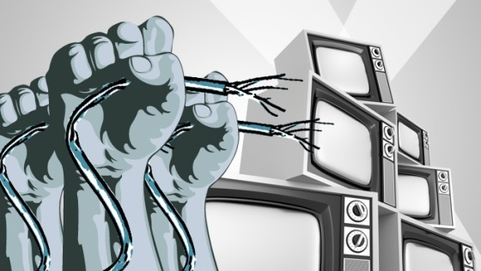
Combining the Xbox One with a Mohu Leaf indoor HDTV antenna and a Hauppauge 955Q USB TV tuner brings the Xbox "closer than ever" to being a stand-alone technology for watching TV shows and movies and playing games, Darrell Etherington writes. "[I]f you stripped my home theater setup down to just the Xbox One, from a media perspective, I'd now be more or less satisfied," he writes.
TechCrunch 5/1/15
http://techcrunch.com/2015/05/01/over-the-air-hdtv-makes-xbox-one-a-near-perfect-cord-cutting-console/

