Microsoft: Xbox Probably Streaming to Smart TVs in 2021
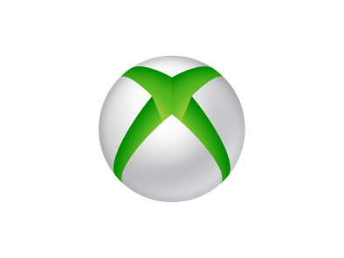
Microsoft's Xbox gaming app will likely reach smart televisions "in the next 12 months," said executive Phil Spencer. The company has been working on streaming games to TVs since 2013.
The Verge 11.24.20
https://www.theverge.com/2020/11/24/21612714/microsoft-xbox-app-tv-xcloud-streaming-app

