Younger Millennials OK with Ads but Don't Remember Them
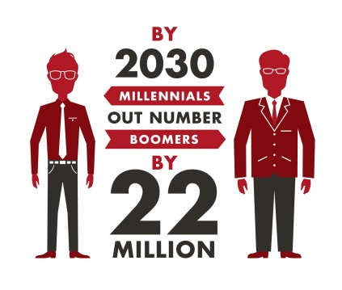
Just over half of 18 to 24 year olds say they're fine with ads during free mobile content, compared to 46% of those between 25 and 35, Nielsen reports. Less than 2% of millennials switch TV channels during ad breaks, but the age group had "the lowest program engagement and lowest ad memorability scores during the studied shows," the report stated.
MediaPost Communications 3/2/17
http://www.mediapost.com/publications/article/296331/millennials-dont-mind-commericals-but-register-l.html
Image source:
http://2.bp.blogspot.com/-oKUGPknTui8/UoJ3iraVVvI/AAAAAAAABFY/HsoncTYYjyY/s1600/millennials_a7.jpg

