YouTube Gives Creators More Music Options
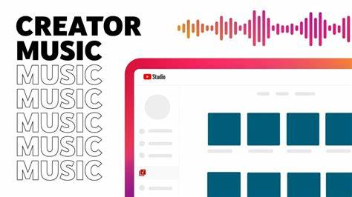
YouTube's Creator Music online marketplace is now available to all US participants in the company's Partner Program, and the site is testing a new tool that adds multiple multilingual tracks. Creator Music explains songs' rights agreements in simple language and offers license purchases as well as the ability to find songs for which revenue sharing is an option.
Social Media Today 2.13.23
https://www.socialmediatoday.com/news/youtube-tests-multi-language-audio-tracks-expands-creator-music/642683/

