YouTube Test Will Auto-Detect Products Featured In Videos
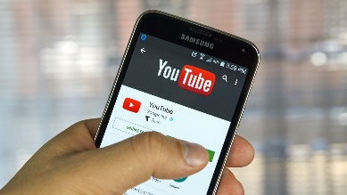
YouTube is experimenting with a new tool that will auto-detect products that appear in users’ videos, and then provide pertinent links to related content below. In addition to detected products, YouTube will also suggest videos containing “related products,” it says, with the list of items appearing in between recommended videos below the video player (pictured above).
Tubefilter 3.23.21
https://www.tubefilter.com/2021/03/23/youtube-test-auto-detect-products-in-videos/?utm_source=Tubefilter+Newsletters&utm_campaign=715e49497b-Tubefilter+Daily+Recap+-+2016-09-15_COPY_01&utm_medium=email&utm_term=0_09c509c94c-715e49497b-414175190&mc_cid=715e49497b&mc_eid=a906555dbd
Image credit:
https://cdn.techjuice.pk/wp-content/uploads/2016/06/Youtube.jpg

