Zuckerberg Apologizes For Facebook Failures
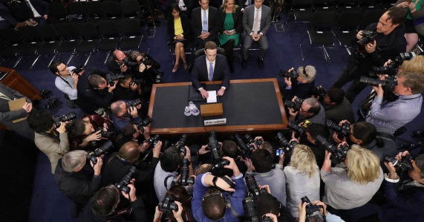
During some five hours of Senate questioning Tuesday, Facebook CEO Mark Zuckerberg apologized several times for his company's privacy failures, disclosed that his company was “working with” special counsel Robert Mueller in the federal probe of Russian election interference and said it was working hard to change its own operations after the harvesting of users’ private data by a data-mining company affiliated with Donald Trump’s campaign.
Associated Press 4.11.18
http://www.tvnewscheck.com/article/112706/zuckerberg-apologizes-for-facebook-failures?utm_source=Listrak&utm_medium=Email&utm_term=Zuckerberg+Apologizes+For+Facebook+Failures&utm_campaign=Pai+Says+Thanks%2c+Reiterates+Reg+Philosophy
Image credit:
https://media1.s-nbcnews.com/j/newscms/2018_15/2394016/180410-mark-zuckerberg-senate-njs-1437_456194339e65d4a16e8a07d03ecd1c2b.nbcnews-fp-1200-630.jpg

