Zuckerberg Unveils His 10-year Plan for Facebook
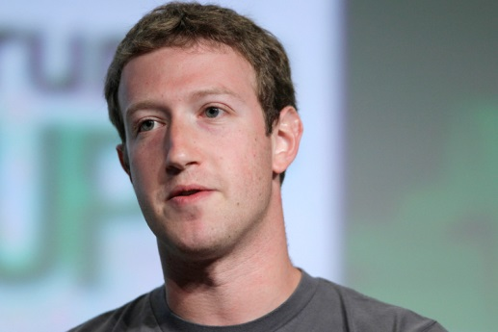
Facebook CEO Mark Zuckerberg has announced a 10-year plan for the social network, with a focus on bolstering apps and having users interact with artificial intelligence to get information and to place orders. The company handles 60 billion messages a day, three times more than the number sent by text, suggesting businesses could be doing more to create message-based marketing and outreach.
Bloomberg 4/12/16
http://www.bloomberg.com/news/articles/2016-04-12/facebook-s-zuckerberg-ushers-in-an-age-of-bots-virtual-reality

