10 Journalists Killed in Afghanistan Attacks
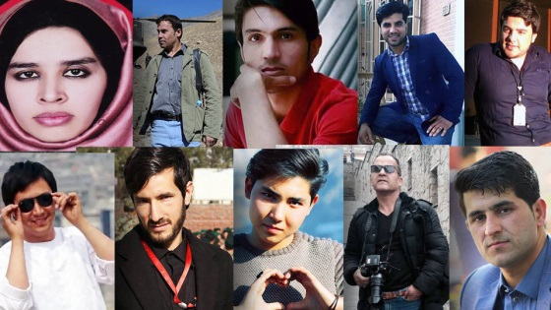
Thirty-one people were killed in a series of Islamic State suicide bombing attacks in Afghanistan on Monday, 10 of whom were journalists. Among the victims were Shah Marai of Agence France Presse and BBC reporter Ahmad Shah.
CNN 4/30/18
https://www.cnn.com/2018/04/30/asia/afghanistan-kabul-blasts-intl/index.html
Image credit:
https://kpfa.org/wp-content/uploads/2018/05/S1_Afghan-Journalists-Killed.jpg

