10 Trends in Digital Content for 2019
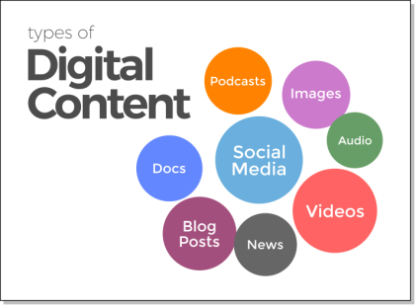
Today any organization working with content has a new responsibility – content accounting. As content has become the new currency, it’s not enough for companies to create content and forget about it. Instead, content has costs associated with it that must be assessed along with the benefits.
Marketing Land 1.2.19
https://marketingland.com/10-trends-in-digital-content-for-2019-management-is-vital-to-success-254631
Image credit:
https://searchlabchicago.com/wp-content/uploads/2018/02/types-of-digital-content.png

