19 Ways To Write Better Digital Content
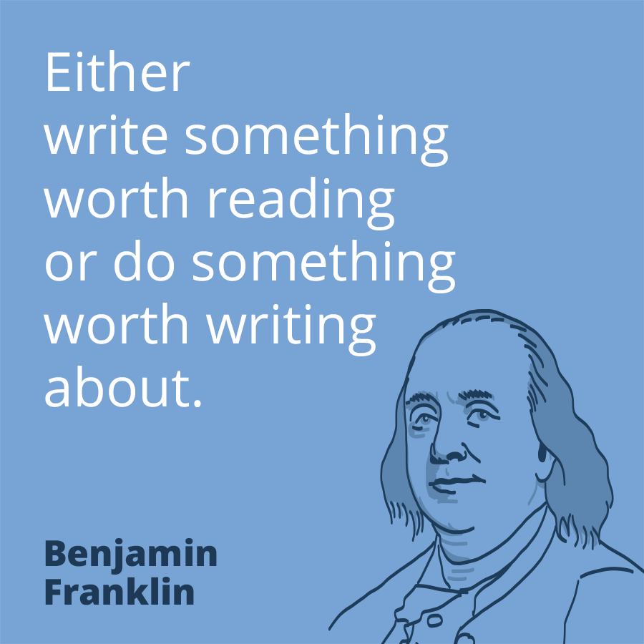
This infographic from Instructional Solutions offers 19 tips for marketers to improve their digital content writing skills, including writing for the target audience, limiting paragraphs to seven lines and making content easy to scan by incorporating headings and bullet points. Additionally, use verbs that energize readers, don't include jargon and adopt an authoritative tone.
Social Media Today 7/22/19
https://www.socialmediatoday.com/news/19-actionable-writing-tips-to-improve-your-digital-marketing-strategy-info/559174/
Image credit:
https://www.prezly.com/frontend/img/landing/public_relations_quotes/pr-quote-benjamin-franklin.png

