1 in 3 People Globally on Social Networks, Most Using Phones
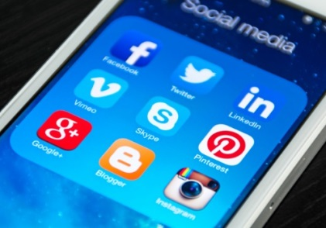
Big gains in emerging markets powered an 8.7% increase in social network use last year, lifting the share to 1 in 3 people around the world, per eMarketer. More than 8 in 10 social network users globally tap their phones for access at least once a month.
eMarketer 1/16/18
https://www.emarketer.com/content/emarketer-unveils-latest-wordwide-social-users-estimates
Image credit:
http://entrecreativos.com/wp-content/uploads/2014/03/socialmedia.jpg

