2016 Election Digital Ad Spending Will Break $1 Billion
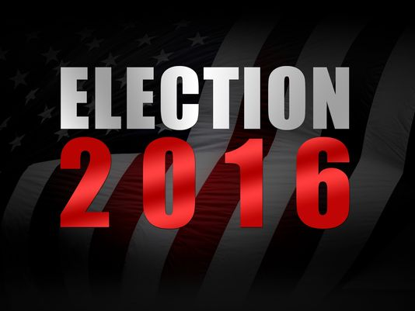
If you're worried you'll see less red, white and blue ads with patriotic symbolism, don't be; the report, "2015–2016 Political Advertising Outlook," said political advertising spending will hit $11.4 billion in 2016, a 20% increase from 2014. Combined spending for this year and next year will reach a staggering $16.5 billion.
Advertising Age 8.18.15
http://adage.com/article/digital/2016-election-digital-spend-break-1-billion/299992/?utm_source=daily_email&utm_medium=newsletter&utm_campaign=adage&ttl=1440455781

