Now, the Trends that Will Shape Advertising in 2017
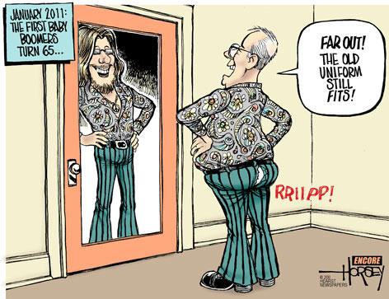
This may be the year when advertisers, and by extension media buyers and planners, come to their senses and begin valuing other demographics again, most notably Baby Boomers, who got left behind in the surge toward Millennials. That’s according to an annual report from Mindshare, which looks at trends for the coming year in advertising.
MediaLife 2.14.17
http://www.medialifemagazine.com/trends-shape-advertising-2017/
Image source:
http://blog.seattlepi.com/davidhorsey/files/library/Boomer-1-7-11-web.jpg

