Why 2017 Could be the Year of Sponsored Podcasts
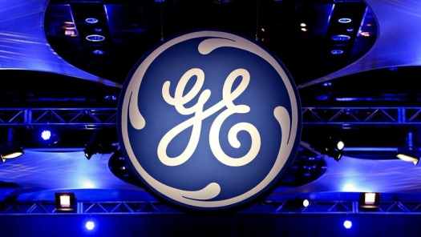
General Electric's success with branded podcasts "The Message" and "LifeAfter" resulted in combined downloads of more than 6 million and have paved the way for other brands and agencies excited about the opportunity to create an intimate connection with consumers.
Digiday 1/9/17
http://digiday.com/publishers/branded-podcasting-double-2017/

