2020 Mobile App, Game Spending Surges
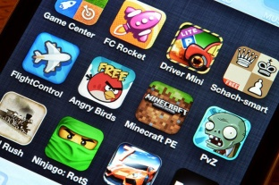
Consumers broke mobile app and game spending records during 2020 surpassing $100 billion for the first time in November with an additional $407.6 million spent via Apple's App Store and Google Play through Christmas, according to Sensor Tower Store Intelligence. TikTok was the non-gaming leader generating $4.7 million worldwide on Christmas.
MediaPost Communications 12.30.20
https://www.mediapost.com/publications/article/359093/global-app-spending-rose-35-on-christmas-reachin.html?edition=120932

