2024 Political Ad Spend Surpasses $1B Mark
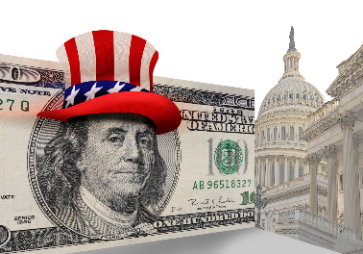
Spending on political advertising ahead of the 2024 election reached $1.06 billion on Oct. 27 -- a significant increase over the $640 million spent at this point in the last presidential election cycle, AdImpact reports. Florida Governor Ron DeSantis leads Republican candidates with spending and reservations at $41.8 million, while spending and reservations for President Joe Biden have topped $40 million as the first Democratic challenger emerges.
Inside Radio 10/31/23
https://www.insideradio.com/free/spending-tops-1-billion-in-2024-election-cycle/article_9a420a6a-77ba-11ee-8076-2bf1e7d19751.html
Image credit:
https://ohiocapitaljournal.com/wp-content/uploads/2021/03/money-politics-capitol.jpg

