2024 Super Bowl Ad Slots Are Nearly Sold Out
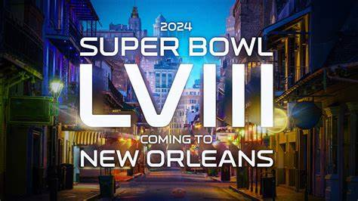
Advertising spots for the 2024 Super Bowl are virtually sold out, an achievement that doesn't typically happen until the final days before the February game, CBS reports. Insiders say 30-second slots have sold for between $6.5 million and $7 million.
Variety 11/2/23
https://variety.com/2023/tv/news/super-bowl-commercials-sold-out-cbs-tv-advertising-1235777413/
Image credit:
https://static.clubs.nfl.com/image/private/t_editorial_landscape_12_desktop/saints/xic9dopdyzbpxyrldbt7

