2 Things That Helped Propel 2015 Mobile Shopping Sales to $100B
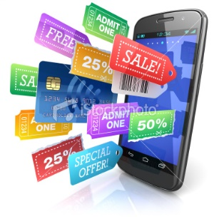
Mobile shopping sales are on pace to hit $100 billion by the end of 2015, in large part due to buy buttons located on mobile applications and one-touch payments options such as Apple Pay, PayPal One Touch and Android Pay, Ruth Reader writes.
VentureBeat 12/25/15
http://venturebeat.com/2015/12/25/in-2015-buy-buttons-tap-to-pay-features-advanced-mobile-shopping/

