30% of Global Social Media Users Will Be On Instagram by 2021
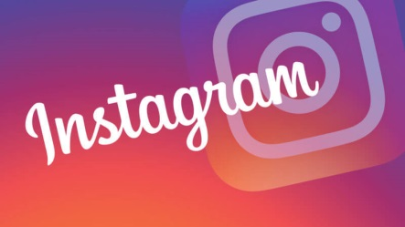
Thirty percent of global social media users will use Instagram by 2021, a 25% rise from its user base this year of 593.7 million, eMarketer reports. Instagram's advertising revenue is expected to increase to $10.87 billion by 2019, up from this year's $4.10 billion.
eMarketer 12.14.17
https://www.emarketer.com/content/emarketer-unveils-first-ever-worldwide-instagram-forecast

