CPJ Reports At Least 57 Journalists Killed In Israel-Gaza War
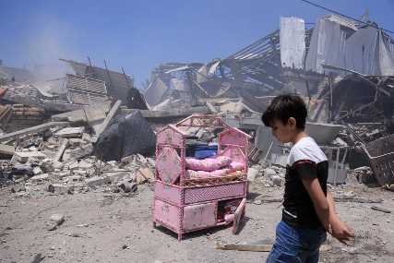
At least 57 of the over 16,000 people killed since the Israel-Gaza war began last month were journalists, the Committee to Protect Journalists reports, reiterating that both sides should avoid targeting members of the press as they work to cover the conflict. There have also been multiple reports of journalists in the region going missing or being injured, detained or threatened.
Committee to Protect Journalists 11.28.23
https://cpj.org/2023/11/journalist-casualties-in-the-israel-gaza-conflict/
Image copyright:
https://static01.nyt.com/images/2021/05/16/world/16israel-civilians1/16israel-civilians1-jumbo.jpg?quality=90&auto=webp

