5 Keys to Crafting Shareable Content
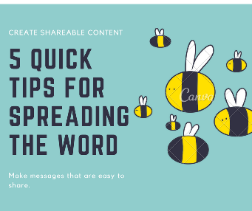
Individuals charged with content creation can create an emotional connection with readers and spur them to hit the share button by taking five steps, including ensuring the "brand or product personifies and embodies someone we want to connect with," suggests Marathon Petroleum's Brandon Daniels. Storytellers also need to "write like a screenwriter" with a focus on moving the action forward, editing and rewriting.
PR Daily 3/8/21
https://www.prdaily.com/create-shareable-content-5-hollywood-storytelling-tips/
Image credit:
https://savardhospitalityconsulting.com/wp-content/uploads/2017/08/Shareable-Content.png

